
Chemistry 3A

Semester One Examination, 2011

Question/Answer Booklet

NAME: ___________________________

TEACHER: ___________________________

Marker use only
Part | Marks  achieved | Marks  available
1 Multiple choice | /50 | 50 (33%)
2 Short answer | /60 | 60 (40%)
3 Extended answers | /40 | 40 (27%)
TOTAL |  | 150 (100%)

%

Time allowed for this paper
Reading time before commencing work: Ten minutes
Working time for paper: Two and a half hours

Materials required/recommended for this paper
To be provided by the supervisor
This Question/Answer Booklet
Separate Multiple Choice Answer Sheet
Separate Chemistry Data Sheet

To be provided by the candidate
Standard Items: Pens, pencils, eraser or correction fluid and ruler
Special Items: A 2B, B or HB pencil for the separate Multiple Choice Answer Sheet and calculators satisfying the conditions set by the Curriculum Council for this subject.

Important note to candidates
No other items may be taken into the examination room. It is your responsibility to ensure that you do not have any unauthorised notes or other items of a non-personal nature in the examination room. If you have any unauthorised material with you, hand it to the supervisor before reading any further.

Structure of this paper

Part | Number of questions  available | Number of questions to be attempted | Suggested working time  (minutes) | Marks available
1 Multiple choice | 25 | ALL | 50 | 50 (33%)
2 Short answer | 9 | ALL | 60 | 60 (40%)
3 Extended answers | 4 | ALL | 30 | 40 (27%)
Total marks |  |  |  | 150 (100%)

Instructions to candidates

Answer the questions according to the following instructions:
Part 1: Answer all questions, using a 2B, B or HB pencil on the separate Multiple Choice Answer Sheet. Do not use a ballpoint or ink pen.

If you consider that two or more of the alternative responses are correct, choose the one you think is best. If you think you know an answer, mark it even if you are not certain you are correct. Marks will not be deducted for incorrect answers.

Feel free to write or do working on the question paper; many students who score high marks on the Multiple Choice Section do this.

Parts 2 and 3 Write your answers in the spaces provided in this Question/Answer Booklet. A blue or black ball point or ink pen should be used.

Questions containing specific instructions to show working should be answered with a complete, logical, clear sequence of reasoning showing how the final answer was arrived at. Correct answers which do not show working will not be awarded full marks.

The examiners recommend that you spend your reading time mainly reading the Instructions to Candidates and Parts 2 and 3.

At the end of the examination make sure that your name is on your Question/Answer Booklet and on your separate Multiple Choice Answer Sheet.

Chemical Equations
For full marks, chemical equations should refer only to those specific species consumed in the reaction and the new species produced. These species may be ions [for example Ag⁺_{(aq)}], molecules [for example NH_{3(g)}, CH₃COOH_{(l)}, CH₃COOH_{(aq)}] or solids [for example BaSO_{4(s)}, Cu_{(s)}, Na₂CO_{3(s)}].

PART 1 (50 marks = 33% of paper)

Question 1.

The property of an atom which is most responsible for chemical behaviour is:

(a) the ratio in which the atom combines with other atoms.

(b) the number of electrons in its valence shell.

(c) the number of neutrons contained in the nuclei of the atom.

(d) the number of unpaired s orbital electrons.

Question 2.

Chlorine and bromine are both members of Group 17 in the periodic table.
A chlorine and a bromine atom should have the same:

- number of protons in the nuclei.

- total number of electrons around their nuclei.

- characteristic of gaining one electron per atom to form an ion.

- atomic number and nuclear charge.

Question 3.

The first five ionisation energies of an element are as follows:

744 kJ mol⁻¹ 1457 kJ mol⁻¹ 7739 kJ mol⁻¹ 10547 kJ mol⁻¹ 13636 kJ mol⁻¹

The element is most likely to be:

- Na

- Mg

- Al

- Si

Question 4.

The metal X has a sulfide X₂S₃. The correct formula for its bromide is

- X₂Br₃
- XBr₂
- XBr
- XBr₃

Question 5.

The shape of the molecules formed by the combination of atoms with the electronic configurations:

2, 7 and 2, 5 will be:

- linear

(b) pyramidal

(c) bent

(d) trigonal planar

Question 6.

Which of the following elements is the most electronegative?

(a) Na

(b) S

(c) Cl

(d) Br
Question 7.

Substance Z is a white crystalline solid that melts at 81 °C. Z does not conduct electricity in either the solid or the liquid state.

(a) Ionic.

(b) Covalent network.

(c) Covalent molecular.

(d) Metallic.

Question 8.

The oxidation of sulfur dioxide to sulfur trioxide is an exothermic reaction which may reach a state of equilibrium as represented by:

2SO_{2 (g)} + O_{2 (g)} 2SO_{3 (g)}
D

Which of the following changes will increase the equilibrium concentration of sulfur trioxide?
(a) Increasing the temperature of the reaction mixture

(b) Decreasing the volume of the reacting system.

(c) Add a suitable catalyst.

(d) Reducing some of the oxygen gas.

Question 9.

How many pairs of non-bonding electrons are on the carbon atom in a molecule of CO₂?

(a) none

(b) 1

(c) 2

(d) 3
Question 10.

The equation below shows carbon and hydrogen reacting to form methane.

C _{(s)} + 2H_{2 (g)} CH_{4 (g)} + 75 kJ
D

Which of the following gives the correct expression for the equilibrium constant for this reaction?

(a) 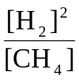

(b) 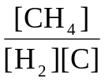

(c) 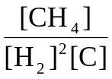

(d) 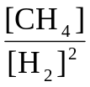

Question 11.

The equilibrium constant, K, for the reaction,

2H_{2 (g)} + O_{2 (g)} 2H₂O _{(g)} , is equal to 2 x 10⁸¹ at 25 ºC.
D

This value suggests that:

(a) this reaction favours the forward reaction slightly more than the reverse reaction.

(b) this reaction favours the reverse reaction slightly more than the forward reaction.

(c) this reaction virtually goes to completion with little reversal.

(d) this reaction virtually does not proceed forward and largely favours the reactants.

The following information refers to Questions 12 and 13.

The potential energy diagram for the following reaction is shown below.

CO (g) + NO₂ (g) CO₂ (g) + NO (g)
D

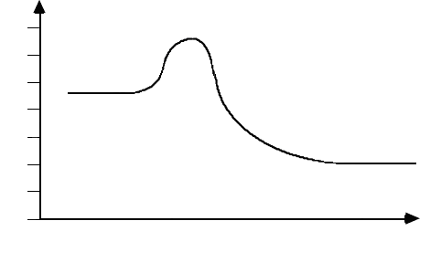
Reaction coordinate

500

400

300

200

100

0

-100

-200

CO (g) + NO₂ (g)
CO₂ (g) + NO (g)
Potential
Energy
(kJ)

Question 12.

For the forward reaction, the heat of reaction (ΔH) and the activation energy (E_{a}) are

(a) ΔH = + 250 kJ ; Ea = 200 kJ

(b) ΔH = + 250 kJ ; Ea = 400 kJ

(c) ΔH = - 250 kJ ; Ea = 400 kJ

(d) ΔH = - 250 kJ ; Ea = 200 kJ

Question 13.

At equilibrium, which one of the following statements is true?

(a) The activation energies of the forward and reverse reactions are equal.

(b) The rates of the forward and reverse reactions are zero.

(c) The rate of production of CO equals the rate of production of CO₂.

(d) The concentrations of the reactants equal the concentrations of the products.

Question 14.

Which of the following best describes the molecular shape and molecular polarity in a PCl₃ molecule?

(a) triangular planar, non-polar

(b) triangular planar, polar

(c) pyramidal, non-polar

(d) pyramidal, polar

Question 15.

Which of the following equations correctly represents the second ionisation energy of Aluminium?

(a) A1⁺ _{(s)} A1⁺² _{(g)} + 1e⁻

(b) A1 _{(s)} A1⁺³ _{(g)} + 3e⁻

(c) A1⁺ _{(g)} A1⁺² _{(g)} + 1e⁻

(d) A1⁺² _{(s)} A1⁺³ _{(g)} + 1e⁻

Question 16.

As you go down Group 14 from C to Pb, which of the options below correctly describes the trends in the characteristics of the elements?

Electronegativity 1st Ionisation Energy Atomic Radius

(a) Decreases Decreases Increases

(b) Increases Decreases Decreases

(c) Decreases Increases Increases

(d) Increases Increases Decreases

Question 17.

The concentration of K⁺ ions in 100 mL of 0.0500M, K₂CO₃ solution, in g L⁻¹, is

(a) 0.196 g L⁻¹

(b) 0.391 g L⁻¹

(c) 1.96 g L⁻¹

(d) 3.91 g L⁻¹

Question 18.

Hydrogen and chlorine react according to the equation

H_{2 (g)} + Cl_{2 (g)} → 2HCl _{(g)}

3 mole of H₂ and 2 mole of Cl₂ are placed in a vessel and sealed.
When reaction is complete the vessel will contain:

(a) 5 mole of HCl

(b) 6 mole of HCl and 1 mole of Cl₂

(c) 4 mole of HCl and 1 mole of Cl₂

(d) 4 mole of HCl and 1 mole of H₂

Question 19.

Which of the following particles has 10 electrons, 13 neutrons and 12 protons?

(a) Na⁺

(b) Ne⁻

(c) Mg²⁺

(d) Al³⁺

Question 20.

A 100 mL sample of helium exerts a pressure of 100 kPa at 10°C. The volume of the container is reduced to 50 mL and then the temperature is increased to 20°C.

The pressure now exerted by the helium, in kPa, is closest to

(a) 400 kPa

(b) 207 kPa

(c) 50 kPa

(d) 100 kPa

Question 21.

In moving left to right across a period of the periodic table, what trends happen to the following properties?

 | Atomic radius | First ionization energy | Electronegativity
(a) | Decrease | Decrease | Increase
(b) | Increase | Increase | Increase
(c) | Decreases | Increases | Increases
(d) | Increase | Increase | Decrease

Question 22.

Zinc metal reacts with 0.1 M hydrochloric acid to form hydrogen gas and zinc chloride solution. The production of hydrogen gas is more vigorous if the zinc is powdered, rather than in large pieces, because the:

(a) activation energy of the reaction is lower.

(b) activation energy of the reaction is higher.

(c) frequency of collisions between zinc metal and hydrogen ions is higher.

(d) fraction of reactant particles with sufficient energy to react is higher.

Question 23.

0.10 mole of C₄H₉OH reacts completely with molecular oxygen, O₂ forming carbon dioxide and water (combustion).
The number of mole of oxygen molecules used is

(a) 0.50 mol

(b) 0.55 mol

(c) 0.60 mol

(d) 0.65 mol

Questions 24 and 25 refer to the following information.

Dolomite is a mineral that contains metal carbonates. The amount of calcium carbonate CaCO₃ (molar mass = 100.1 g mol⁻¹) in the ore dolomite, can be determined by gravimetric analysis. The dolomite sample is dissolved in acid and the calcium ions Ca²⁺ present, are precipitated as calcium oxalate CaC₂O₄ (molar mass =
128.1 g mol⁻¹). The calcium oxalate is filtered, dried and strongly heated to form calcium oxide, CaO (molar mass = 56.1 g mol⁻¹).

Question 24.

In one analysis the mass of dolomite used was 3.72 g. The mass of calcium oxide formed was found to be 1.24 g. The percentage of calcium carbonate in the dolomite sample is closest to:

(a) 26.9 %

(b) 33.3 %

(c) 56.0 %

(d) 59.5 %

Question 25.

Two possible sources of error in this analysis are:
I the precipitate of calcium oxalate is not rinsed with water after being filtered.
II the calcium oxide is not heated to constant mass.

Which of these two errors, if any, would lead to a result that is too high?

(a) I only

(b) II only

(c) both I and II

(d) neither I nor II

END OF PART 1

PART 2 (60 marks)

Answer ALL questions in Part 2 in the spaces provided below.

Question 26.

Give fully balanced equations for the reactions which occur (if at all) in the following experiments.
Use ionic equations where appropriate. In each case describe observations such as colour changes, precipitate formation (give the colour), or gas evolution (give the colour or describe as colourless) resulting from the chemical reaction.

(a) Sodium carbonate solution is added to excess dilute hydrochloric acid.

Equation ___________________________________________________________________
[2 marks]

Observation _________________________________________________________________
___________________________________________________________________________
[1 marks]

(b) Iron(III) nitrate solution is added to sodium hydroxide solution.

Equation ___________________________________________________________________
[2 marks]

Observation _________________________________________________________________
___________________________________________________________________________
[1 marks]

(c) Dilute sulfuric acid is added to a solution of sodium chromate.

Equation ___________________________________________________________________
[2 marks]

Observation _________________________________________________________________
___________________________________________________________________________
[1 marks]

Question 27.

Complete the table below by drawing correct Lewis (electron dot) diagrams, the molecular shape, indicating whether the substance is polar or non polar.

Formula | Lewis (electron dot) diagram | Name of molecule shape | Polar or  non polar
SO₂
PI₃
Cl₂O
CO₃²⁻ |  |  | Not required

[11 marks]

Question 28.

Classify the following solid substances by writing them in the appropriate column in the table below.

silicon carbide | iodine | copper (II) oxide | brass
dry ice (CO₂) | potassium permanganate | sulfur | barium sulphate
solder | graphite | silver | diamond

Ionic Solid | Metallic Solid | Covalent Network Solid | Covalent Molecular solid

[6 marks]

Question 29.

Classify the following substances according to the major intermolecular force found in the substance.

liquid nitrogen | liquid hydrogen sulfide | liquid carbon disulfide
liquid ammonia | liquid ethanol | liquid propane

Dispersion forces | Dipole-dipole | Hydrogen Bonding

[3 marks]

Question 30.

The graph below shows the boiling point for the groups 14-17 hydrides plotted against period. Using your knowledge of Van der Waal forces explain the anomalous behaviour of NH₃, H₂O and HF seen in the graph.

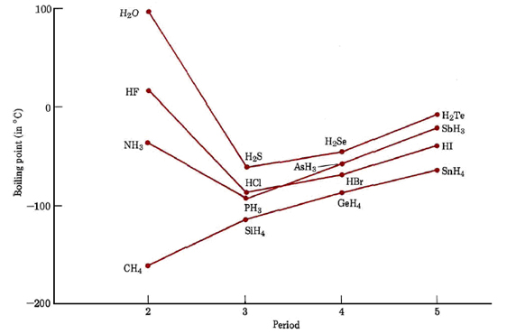

..........................................................................................................................................

..........................................................................................................................................

..........................................................................................................................................

..........................................................................................................................................

..........................................................................................................................................

..........................................................................................................................................

..........................................................................................................................................

..........................................................................................................................................

..........................................................................................................................................

..........................................................................................................................................

[4 marks]
Question 31.

Methanol can be made from natural gas by converting the methane in the natural gas to carbon monoxide, CO, and hydrogen, H₂, and then combining these two gases to make the methanol, CH₃OH. This final step involves the equilibrium:

CO _{(g)} + 2H_{2 (g)} CH₃OH _{(g)} ΔH = - 91 kJ
D

Complete the table below to show what would happen to the equilibrium concentration of methanol when the following changes are made. Include a short explanation to account for each change applying Le Chateliers principle.

Change made to the equilibrium mixture | Effect of the change on the equilibrium concentration of methanol. Use the terms “increases”, “decreases” or “no change”  AND short explanation
The equilibrium mixture is compressed to increase the pressure.
The equilibrium mixture is cooled to reduce the temperature.
Additional hydrogen is added to the equilibrium mixture.
An appropriate catalyst is added

[8 marks]
Question 32.

The production of ammonia from nitrogen and hydrogen is an exothermic process according to the equation:

N_{2 (g)} + 3H_{2 (g)} 2NH_{3 (g)} + 92kJ
D

Nitrogen, hydrogen and ammonia, at time 0 min are in equilibrium in a reaction vessel at 500 ^{O}C. Changes are made to the conditions of the system after 7 minutes, 15 minutes, and 19 minutes. The effects of these changes are represented in the graph below.

Concentration vs Time Graph
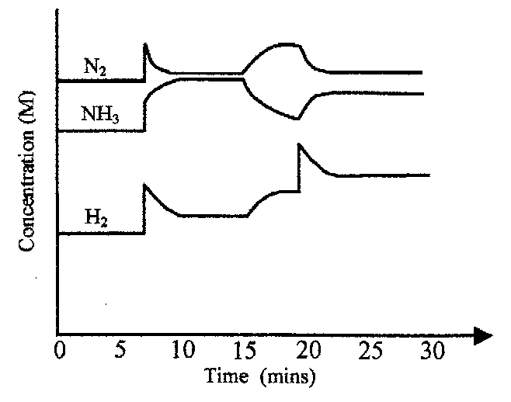

(a) Suggest what particular changes have been imposed at

(i) 7 minutes: ______________________________________________ [1 marks]
(ii) 15 minutes: _____________________________________________ [1 marks]
(iii) 19 minutes: _____________________________________________ [1 marks]

(b) Write the expression for the equilibrium constant for this reaction.

[1 marks]

(c) Account for the changes in concentration of the three substances between the 15 minute and the 19 minute mark.
_________________________________________________________________________________________________________________________________________________________________________________________________________________________________
[2 marks]
Question 33.

The graph below represents the energy changes over the course of a chemical reaction:

CO _{(g)} + NO_{2 (g)} → CO_{2 (g)} + NO _{(g)}
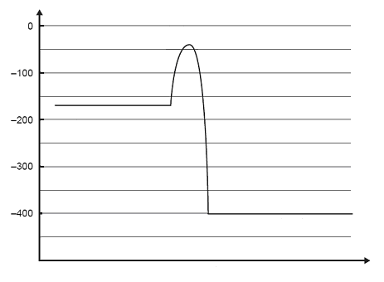
Reaction coordinate
Potential
Energy
(kJ)
CO _{(g)} + NO_{2 (g)}
CO_{2 (g)} + NO _{(g)}

(a) Give the magnitude and sign of the ΔH for the forward reaction in kJ

_______________________________________________________________
[1 marks]

(b) Give the activation energy for the reverse reaction in kJ

_______________________________________________________________
[1 marks]

(c) Give two reasons explaining why the rate of this reaction increases with increasing temperature.
___________________________________________________________________________________________________________________________________________________________________________________________________________________________________________________________________________________________________________________________
[2 marks]

(d) A suitable catalyst is discovered for the reaction. What would be the likely effect of the catalyst on the ΔH ? Explain your answer.
____________________________________________________________________________________________________________________________________________________________________________________________________________________________________________________________
[2 marks]

Question 34.

A bottle of soft drink was placed on an electronic balance and weighed. The cap was
removed and placed next to the bottle on the balance. The mass of the cap, bottle and
its contents was monitored. The results are shown in the graph. The experiment was
conducted at 25°C and 101.3 kPa. Assume that no evaporation has occurred.
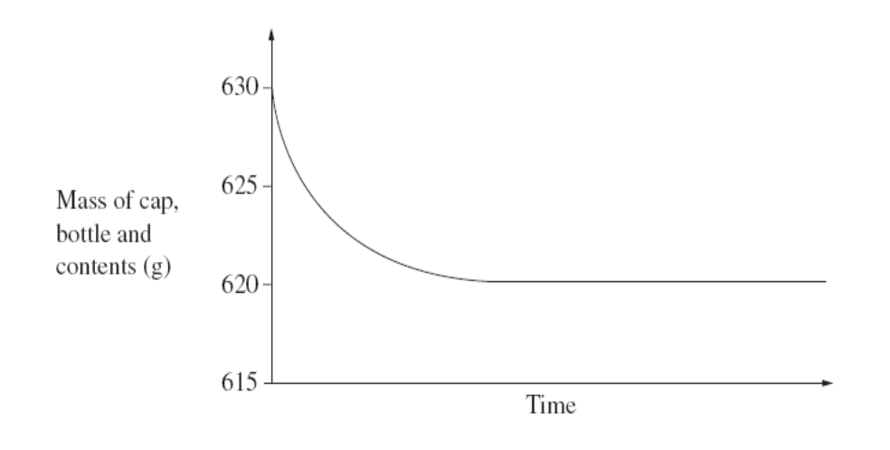

(a) Identify the gas released.

_______________________________________________________________________
[1 marks]

- If the soft drinks volume was 500 mL, what was the concentration in ppm of the gas in the initial solution? (assume density = 1g/mL)
..........................................................................................................................................

..........................................................................................................................................

..........................................................................................................................................

..........................................................................................................................................
[3 marks]
(c) Calculate the volume of the gas released.

..........................................................................................................................................

..........................................................................................................................................

..........................................................................................................................................

..........................................................................................................................................

..........................................................................................................................................

[3 marks]
END OF PART 2

This page has been intentionally left blank.

PART 3 (40 marks)

Answer ALL questions in Part 3. The calculations are to be set out in detail in this
Question/Answer Booklet. Marks will be allocated for correct working, correct equations and clear setting out, even if you cannot complete the problem. Note that if an incomplete answer is given only partial marks will be awarded.
When questions are divided into sections, clearly distinguish each section using (a), (b), and so on. Express your final numerical answers to three (3) significant figures where appropriate, and provide units where applicable. Information which may be necessary for solving the problems is located on the separate Chemistry Data Sheet.

Question 35.

A 3.00 g sample of crude zinc sulfide ore containing sand and clay as impurities was roasted completely in air, according to the reaction below.

ZnS _{(s)} + O_{2 (g)} → Zn _{(s)} + SO_{2 (g)}

The sulfur dioxide evolved was passed into 0.300 mol L⁻¹ potassium dichromate solution. It was found that 31.9 mL of the potassium dichromate solution was required to react completely with the gas evolved.

Cr₂O₇²⁻ _{(aq)} + 2H⁺ _{(aq)} + 3SO_{2 (g)} → 2Cr³⁺ _{(aq)} + H₂O _{(l)} + 3SO₄²⁻ _{(aq)}

Calculate the percentage by mass of pure zinc sulfide in the crude ore.
[7 marks]

..........................................................................................................................................

..........................................................................................................................................

..........................................................................................................................................

..........................................................................................................................................

..........................................................................................................................................

..........................................................................................................................................

..........................................................................................................................................

..........................................................................................................................................

..........................................................................................................................................

..........................................................................................................................................

..........................................................................................................................................

..........................................................................................................................................

..........................................................................................................................................

..........................................................................................................................................

..........................................................................................................................................

..........................................................................................................................................

..........................................................................................................................................

..........................................................................................................................................

..........................................................................................................................................

..........................................................................................................................................

..........................................................................................................................................

..........................................................................................................................................

..........................................................................................................................................

..........................................................................................................................................

..........................................................................................................................................

..........................................................................................................................................

..........................................................................................................................................

..........................................................................................................................................

..........................................................................................................................................

..........................................................................................................................................

..........................................................................................................................................

..........................................................................................................................................

..........................................................................................................................................

..........................................................................................................................................

..........................................................................................................................................

..........................................................................................................................................
Question 36.

In a laboratory experiment, a student prepared insoluble aluminium carbonate Al₂(CO₃)₃ by a precipitation reaction. She added 250.0 mL of 1.00 mol L⁻¹ aluminium nitrate solution to 500.0 mL of 0.500 mol L⁻¹ sodium carbonate solution.

(a) Write a balanced ionic equation for the precipitation reaction.
[1 marks]

(b) Determine the limiting reagent in this experiment.
[6 marks]

(c) Calculate the mass of aluminium carbonate precipitated.
[3 marks]

(d) What would be the concentration of the excess reagent in mol L⁻¹ in the final solution?

[3 marks]
..........................................................................................................................................

..........................................................................................................................................

..........................................................................................................................................

..........................................................................................................................................

..........................................................................................................................................

..........................................................................................................................................

..........................................................................................................................................

..........................................................................................................................................

..........................................................................................................................................

..........................................................................................................................................

..........................................................................................................................................

..........................................................................................................................................

..........................................................................................................................................

..........................................................................................................................................

..........................................................................................................................................

..........................................................................................................................................

..........................................................................................................................................

..........................................................................................................................................

..........................................................................................................................................

..........................................................................................................................................

..........................................................................................................................................

..........................................................................................................................................

..........................................................................................................................................

..........................................................................................................................................

..........................................................................................................................................

..........................................................................................................................................

..........................................................................................................................................

..........................................................................................................................................

..........................................................................................................................................

..........................................................................................................................................

..........................................................................................................................................

..........................................................................................................................................

..........................................................................................................................................

..........................................................................................................................................

..........................................................................................................................................

..........................................................................................................................................

..........................................................................................................................................

..........................................................................................................................................

..........................................................................................................................................

Question 37.

The production of the fertiliser, di-ammonium hydrogen phosphate, (NH₄)₂HPO₄, from rock phosphate (impure calcium phosphate), can be represented by the following reaction sequence.

Step 1

Ca₃(PO₄)_{2 (s)} + 3H₂SO_{4 (aq)} → 2H₃PO_{4 (aq)} + 3CaSO_{4 (s)}

Step 2

H₃PO_{4 (aq)} + 2NH_{3 (g)} → (NH₄)₂HPO_{4 (s)}

- What mass of rock phosphate would be required to produce 1.00 tonne (1000 kg) of di-ammonium hydrogen phosphate if the rock phosphate contains 70.0 % by mass calcium phosphate? You may assume that the impurities in the rock phosphate do not react with the sulfuric acid or take part in the reaction.

[7 marks]

- What volume of ammonia gas measured at STP would be needed to bring about the above conversion?

[3 marks]

..........................................................................................................................................

..........................................................................................................................................

..........................................................................................................................................

..........................................................................................................................................

..........................................................................................................................................

..........................................................................................................................................

..........................................................................................................................................

..........................................................................................................................................

..........................................................................................................................................

..........................................................................................................................................

..........................................................................................................................................

..........................................................................................................................................

..........................................................................................................................................

..........................................................................................................................................

..........................................................................................................................................

..........................................................................................................................................

..........................................................................................................................................

..........................................................................................................................................

..........................................................................................................................................

..........................................................................................................................................

..........................................................................................................................................

..........................................................................................................................................

..........................................................................................................................................

..........................................................................................................................................

..........................................................................................................................................

..........................................................................................................................................

..........................................................................................................................................

..........................................................................................................................................

..........................................................................................................................................

..........................................................................................................................................

..........................................................................................................................................

..........................................................................................................................................

..........................................................................................................................................

..........................................................................................................................................

..........................................................................................................................................

..........................................................................................................................................

..........................................................................................................................................

Question 38.

“An understanding of the three dimensional structure of a covalent molecule enables its polarity and intermolecular forces to be predicted.”

Expand on this statement by discussing the following topics;
(a) Valence electron pair repulsion theory.
(b) Shapes of molecules.
(c) Molecular polarity.
(d) Intermolecular forces.

The following table of data for some commonly known covalent molecular substances may be useful for in answering your question. Your answer could also include any other appropriate molecules as examples.

Substance | Boiling point
methane | -162 ºC
water | 100 ºC
carbon dioxide | - 78 ºC (sublimes)
ammonia | - 33 ºC

Marks are awarded principally for the relevant chemical content of your answer, but some marks can also be gained for clarity in arranging a reasonable amount of material in a coherent form. It is suggested that you write between 1½ and 2 pages to answer the question.

[10 marks]
..........................................................................................................................................

..........................................................................................................................................

..........................................................................................................................................

..........................................................................................................................................

..........................................................................................................................................

..........................................................................................................................................

..........................................................................................................................................

..........................................................................................................................................

..........................................................................................................................................

..........................................................................................................................................

..........................................................................................................................................

..........................................................................................................................................

..........................................................................................................................................

..........................................................................................................................................

..........................................................................................................................................

..........................................................................................................................................

..........................................................................................................................................

..........................................................................................................................................

..........................................................................................................................................

..........................................................................................................................................

..........................................................................................................................................

..........................................................................................................................................

..........................................................................................................................................

..........................................................................................................................................

..........................................................................................................................................

..........................................................................................................................................

..........................................................................................................................................

..........................................................................................................................................

..........................................................................................................................................

..........................................................................................................................................

..........................................................................................................................................

..........................................................................................................................................

..........................................................................................................................................

..........................................................................................................................................

..........................................................................................................................................

..........................................................................................................................................

..........................................................................................................................................

..........................................................................................................................................

..........................................................................................................................................

..........................................................................................................................................

..........................................................................................................................................

..........................................................................................................................................

..........................................................................................................................................

..........................................................................................................................................

..........................................................................................................................................

..........................................................................................................................................

..........................................................................................................................................

..........................................................................................................................................

..........................................................................................................................................

..........................................................................................................................................

..........................................................................................................................................

..........................................................................................................................................

..........................................................................................................................................

..........................................................................................................................................

..........................................................................................................................................

..........................................................................................................................................

..........................................................................................................................................

..........................................................................................................................................

..........................................................................................................................................

..........................................................................................................................................

..........................................................................................................................................

..........................................................................................................................................

..........................................................................................................................................

..........................................................................................................................................

..........................................................................................................................................

..........................................................................................................................................

..........................................................................................................................................

..........................................................................................................................................

..........................................................................................................................................

..........................................................................................................................................

..........................................................................................................................................

..........................................................................................................................................

..........................................................................................................................................

..........................................................................................................................................

..........................................................................................................................................

..........................................................................................................................................

..........................................................................................................................................

..........................................................................................................................................

..........................................................................................................................................

..........................................................................................................................................

..........................................................................................................................................

..........................................................................................................................................

..........................................................................................................................................

..........................................................................................................................................

..........................................................................................................................................

..........................................................................................................................................
END OF EXAM

